**Test considerations for performing platelet and leukocyte count assasys for** **in vitro hemocompatibility assessment of cardiovascular materials per ASTM F2888-19 standard**

This document provides details that will be helpful in successfully performing thrombogenicity screening of biomaterials and medical devices per ASTM F2888-19. This document augments ASTM F2888-19 and contains the following details:

i) Test methodology for performing platelet and leukocyte count assays

ii) Details about choice of positive controls

iii) Adjustment of blood anticoagulant concentration

iv) Data for platelet and leukocyte assays for different anticoagulation strategies

v) Discussion on test sensitivity for platelet and leukocyte count assays

1. Test Methodology

The “MATERIALS and METHODS” section of Lu et al. 2021 ( <https://www.ncbi.nlm.nih.gov/pmc/articles/PMC8490275/>) contains all the details about experimental setup, test components, anticoagulation strategy, and test procedures for both platelet and leukocyte count assays

1. Choice of positive control materials

Our study used the following three materials as positive controls for both platelet and leukocyte count assays: i) Buna, ii) Glass, and iii) Latex. Figure 1 below shows the test results from our study comparing the positive controls with various biomaterials. Our results showed that the platelet counts for all three positive controls were statistically significantly different when compared to the biomaterials. We believe that any of these positive controls could be used for the platelet count assay while following the ASTM F2888-19 standard.

1. Adjustment of blood anticoagulant concentration

The default blood heparin concentrations recommended in the ASTM F2888-19 standard are: (1) 2 U/ml for the recalcified and heparinized citrate blood and (2) 1 U/ml for directly heparinized blood. Due to inherent donor variability in blood coagulation response to heparin dosage, it is acceptable to use a heparin concentration that is slightly lower or higher (< 1U/ml difference) than the default concentrations to increase test sensitivity or blood stability for blood from some donors, as long as the test results for the negative and positive controls are within the assay validity range stated in Clause 14.2 of the ASTM F2888-19 standard. A detailed discussion on heparin concentration is provided in the DISCUSSION section of Lu et al. 2021 (<https://www.ncbi.nlm.nih.gov/pmc/articles/PMC8490275/>)

1. Assay data

Figure 1 and 2 ( <https://www.ncbi.nlm.nih.gov/pmc/articles/PMC8490275/>) contains platelet and leukocyte count assay data for different biomaterials, positive controls, and anticoagulation strategies. The data could be used as references by other test labs while developing their own test procedures.

1. Discussion on test sensitivity of the assays

From our data in Figures 1 and 2 below, even though the directly heparinized blood at 1 U/ml had better leukocyte count differentiation between the positive controls and the biomaterials as compared to the recalcified blood, the test sensitivity associated with the leukocyte counts was lower compared to that of the platelet counts for both recalcified blood and directly heparinized blood . Thus, we believe that leukocyte count alone should not be used as an indicator for thrombogenicity evaluation of biomaterials or medical devices.

The study also showed that the assays does not appear to be sensitive enough to distinguish subtle thrombogenicity differences among different biomaterials. Rather, it is suitable only to differentiate the biomaterials from positive controls. The users of this test method should be aware of this limitation while trying to differentiate performance of different medical device materials.

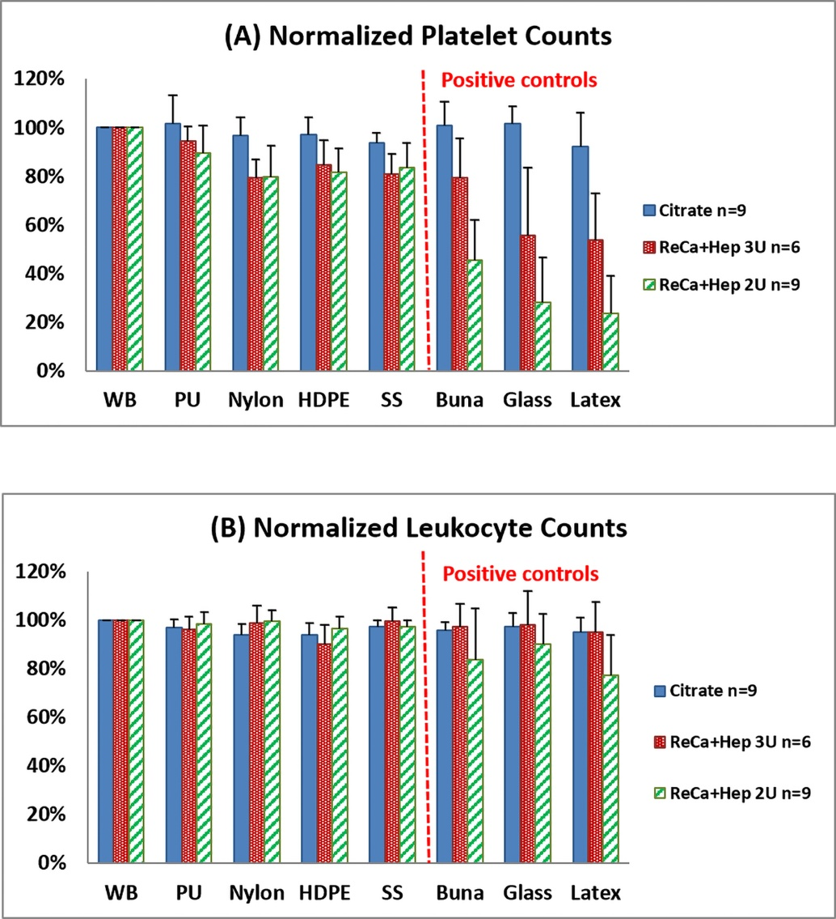

*Figure 1: Platelet (A) and leukocyte (B) count results (normalized to the whole blood negative controls for each blood condition) after blood incubation with the test materials for 1 hour. Blood conditions included sodium citrate anticoagulated blood and recalcified citrated blood with added heparin to a final concentration of 2 U/ml (ReCa+Hep 2U) and 3 U/ml (ReCa+Hep 3U).*

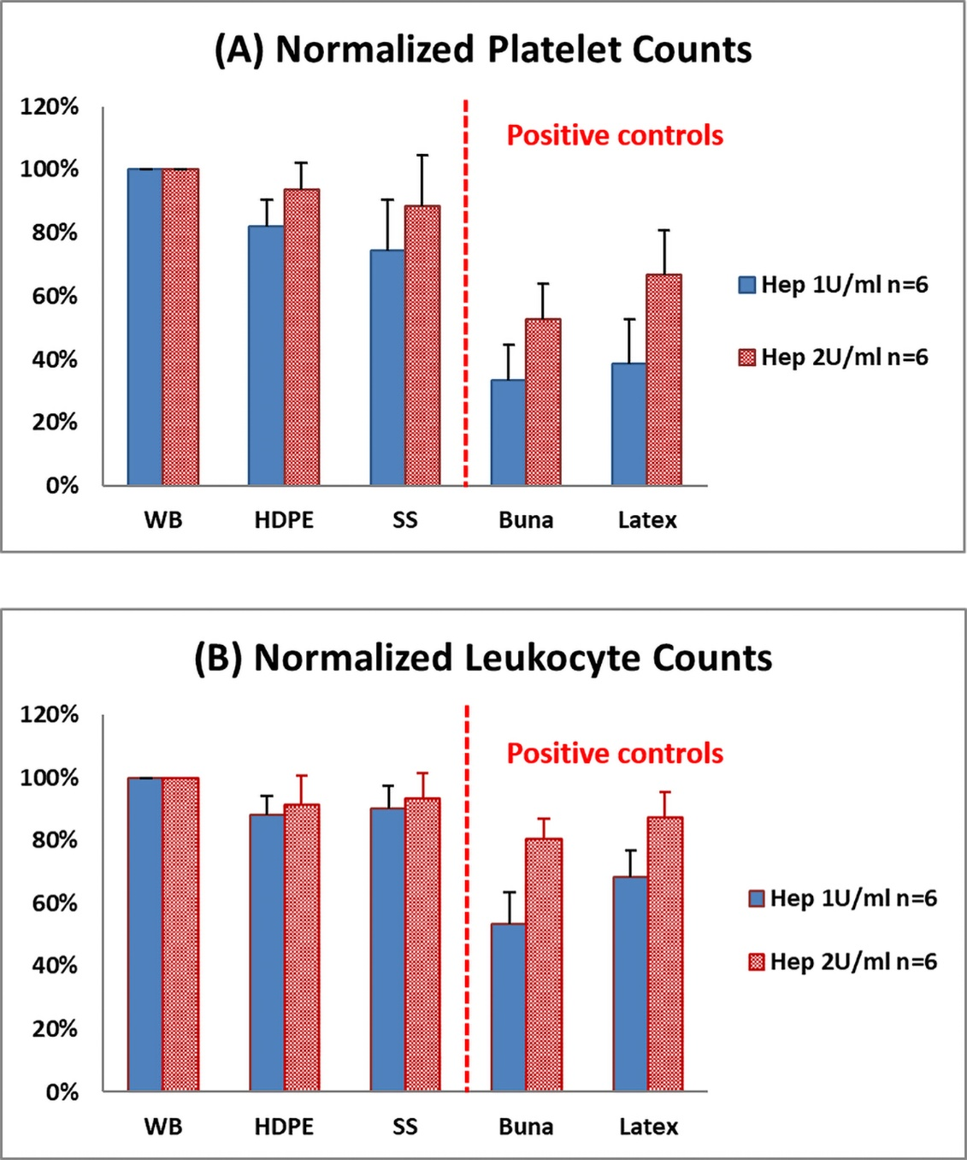

*Figure 2: Platelet (A) and leukocyte (B) count results (normalized to the whole blood negative controls for each blood condition) after blood incubation with the test materials for 1 hour. Tested with directly heparinized blood to concentrations of 1 U/ml and 2 U/ml.*